DIS-Pac-Poly-Marquesas-"Fayaway" Nude-1937

|  |  |
| --- | --- |
| |  | | --- | |  | |

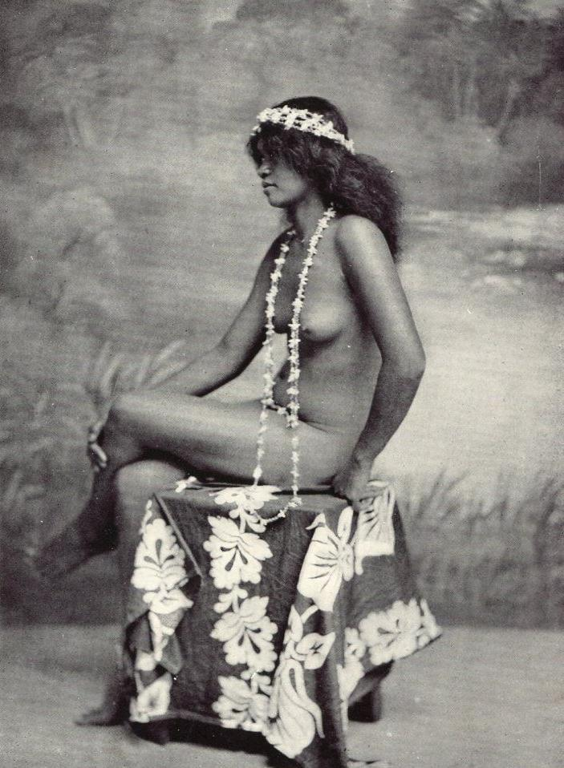

Nude Marquesas Girl, like Melville's Fayaway,1937 Photo-engraving the Sun Engraving Co., London